 Nepal Engineering College

Changunarayan, Bhaktapur, Nepal.

Presented on: 08-09-2019

Proposed to: Manoj Paudel

**Thermal Science Project**

**Project on: Choosing the best Air conditioner for**

**our need with respect to cost and electricity**

**consumption.**

Presented by:

Rupesh Gelal (018-328)

Sajan Kasula(018-330)

Ashutosh Chapagain(018-348)

Pramod Kunwar(018-350)

# Abstract

The purpose of this report is to find the best air conditioner for a specific room and also for the partial fulfillment of ‘Thernal Studies’ in second semester of ‘Computer Engineering’ in Nepal Engineering College. This experiment consideres two air conditioners and finds the best one for the room considered taking in account the initial cost, noise produced, and annual electricity consumed. The value of surface conductance is taken as 1.6 for still air.

Table of Contents

Abstract 2

Problem Description and Objective 3

Calculation 3

For summer 4

For winter 5

Market option and comparison 6

Lloyd LS9A3LN 0.8 Ton Split AC 6

Onida Power Flat- SA093FLT-L 0.8 Ton Split AC 6

Conclusion 7

Table 1 :. Determination of area and thermal resistance 4

Figure 1 :. Layout of room 4

Figure 2 :. Layers of wall 4

# Problem Description and Objective

You need to install an air conditioner for your room. Air conditioner’s capacity is usually given in Tons of Refrigeration. Get an estimate of the capacity required for your room. Then compare the options in the market for the required capacity range (at least two) to find best air conditioner with respect to initial cost and annual electricity consumption.

## Calculation

The room to fit air conditioner has a length 3.77m, breadth 2.15m, and height 2.41m.

We have,

Length(l)= 3.77 m =12.368 ft

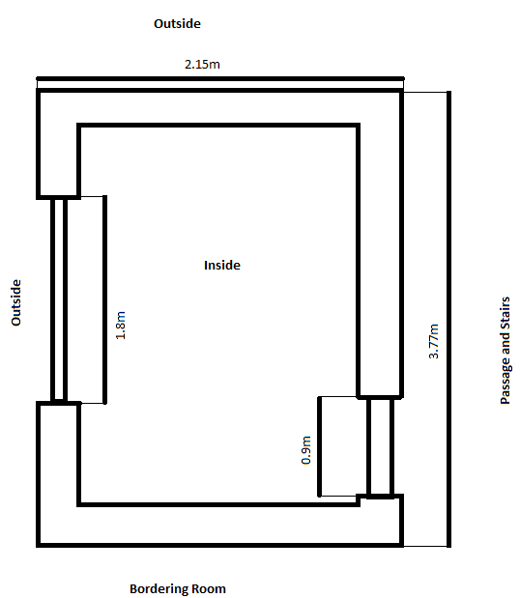Breadth(b)=2.15 m = 7.056 ft

Height(h)= 2.41 m = 7.906 ft

Thickness(t)= 0.1275 m ≈ 0.13m = 0.426 ft

Area of the room(A)= l * b

= 3.77 * 2.15

=8.1055m ^2

Outer area of room = (0.26+3.77) * (0.26+2.15)

=9.7123m^2

The air conditioner’s capacity(C) required for the above room is of 0.75 ton. (Rana, 2011)

Total required capacity = C + 10% of C

=0.75 + 0.075

= 0.825 ton.

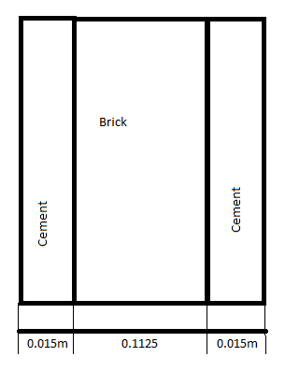0.8ton AC works effectively for the room having area up to 100 sq. ft. So, in this case we can use 0.8ton instead of 0.825ton because our room area is only about 87 sq. ft. The chosen AC capacity accounts for infiltration for this room.

Figure 1 :. Layout of room

Let ‘Rth’ be the thermal resistance of materials. Let ‘lc’,’lb’,’lw’,’ld’ be the thickness of cement, brick, window(glass), door(wood) respectively and ‘kc’,’kb’,’kw’,’kd’ be their thermal conductivity respectively. Let ‘h’ be the surface conductance which is equal to 1.6W/m²K and ‘A’ be the section area. Then we can calculate the thermal resistance of each wall, ceiling and floor using the formula,

Rth = $\frac{2}{hA}+\frac{2lc}{kcA}+\frac{lb}{kbA}$

Similarly, for door,

Rth = $\frac{2}{hA}+\frac{ld}{kdA}$

For window,

Figure 2 :. Layers of wall

Rth = $\frac{2}{hA}+\frac{lw}{kwA}$

Table 1 :. Determination of area and thermal resistance

|  |  |  |  |  |  |  |  |  |
| --- | --- | --- | --- | --- | --- | --- | --- | --- |
|  | Wall 1 | Wall 2 | Wall 3 | Wall 4 | Ceiling | Floor | Door | Window |
| Length | 2.15m | 3.77m | 2.15m | 3.77m | 3.77m | 3.77m | 0.9m | 1.8m |
| Height | 2.41m | 2.41m | 2.41m | 2.41m | Breadth=2.15m | Breadth=2.15m | 2.06m | 1.76m |
| Thickness | 0.13m | 0.13m | 0.13m | 0.13m | 0.13m | 0.13m | 0.03m | 0.0095m |
| Net Area | 5.185m² | 7.2317m² | 5.185m² | 6.9977m² | 8.1055m² | 8.1055m² | 1.854m² | 2.088m² |
| Rth | 0.28K/W | 0.195K/W | 0.279K/W | 0.207K/W | 0.179K/W | 0.179K/W | 0.817K/W | 0.603K/W |

The thermal conductivity of different materials are taken as:

kc=0.721W/mK (engineering.com, 2006)

kb=0.72W/mK (engineering.com, 2006)

kd=0.113W/mK (engineering.com, 2006)

kw=1W/mK (Unknown, 2019)

## For summer

Outside temperature: 37℃

Temperature in bordering rooms: 27℃

Comfortable temperature: 19℃

Heat gained by electrical equipment:

Laptop: Q1a= 400Whrs in 8hrs(1day)

Tube light: Q1b: = 480Whrs in 8hrs(1day)

Heat radiated by people:

Q2=350000 J per hour= 2400Whrs in 24 hrs(1day)

Heat transferred from all the walls: W1 + W2 + W3 + W4 + Wc + Wf

=64.4601023+41.01896867+28.64920102+86.99646219+44.78613286+44.78613286

=310.6969999 W=7456.727998 Whrs in 24 hours(1day)

Heat transferred from windows:29.83982057W=716.1556937Whrs in 24 hours(1day)

Heat transferred from doors:9.786954744W=234.8869139Whrs in 24 hours(1day)

Heat gained by room through walls, window and ceiling: = W1+W2+W3+W4+Wc+Wf+Ww+Wd

=7456.727998+716.1556937+234.8869139

=8407.770605Whrs in 1day

Total heat gained by the room = 8407.770605+400+480+2400=11687.77061whrs in 1 day

## For winter

Outside temperature: 1℃

Temperature in bordering rooms: 18℃

Comfortable temperature: 22℃

Heat gained by electrical equipment:

Laptop: Q1a: = 400Whrs in 8 hrs(1day)

Tube light: Q1b: = 480Whrs in 8hrs(1day)

Heat radiated by people:

Q2=350000 J = 2400Whrs in 24 hrs(1day)

Heat transferred from windows: -34.813124W= -835.514976Whrs in 24 hrs(1day)

Heat transferred from door: -4.893477372 W= -117.4434569Whrs in 24 hrs(1day)

Heat transferred from all the walls: W1 + W2 + W3 + W4+Wc+Wf

= -75.2042-20.5095-14.3246-101.4958725-22.3931-22.3930

=--296.0268442W

=-7104.644261Whrs in 24hrs(1day)

Total heat lost: = W1 + W2 + W3 + W4+ Ww+ Wd+ Wc + Wf

=-7104.644261-835.514976-117.4434569

= -8057.602694 Whrs in 1 day

Net heat lost = Q1a+Q1b-Total heat lost =2400+ 400+480-8057.602694 = -4777.602694 Whrs in 1 day

# Market option and comparison

We have plethora of options for AC in the present market having capacity 0.8ton. There are certain things that we should consider while buying AC. For instance, initial cost, power consumption, energy rating, noise etc. I am going to compare those features and select which fits my need.

## Lloyd LS9A3LN 0.8 Ton Split AC

Capacity = 0.8 ton

Initial cost= Rs. 34,545.

Power consumption=807W

Hours used per day=24 hours

Price=Rs.13 per KWhr

Energy Consumption = 807*24Whrs per day=19368Whrs per day=19.368KWhrs per day=7069.32KWhrs per 1 year

Cost per year= Rs.(13*7069.32)=Rs. 91901.16

Energy rating= 3 star

Noise= 39 dB Indoor Noise

## Onida Power Flat- SA093FLT-L 0.8 Ton Split AC

Capacity = 0.8 ton

Initial cost= Rs.35,432.

Power consumption=850W

Hours used per day=24 hour

Price=Rs.13 per KWhr

Energy Consumption = 850*24Whrs per day=20400Whrs per day=20.4KWhrs per day=7446KWhrs per year

Cost per Year = Rs. (13*7446) = Rs. 96798

Energy rating= 3 star

Noise= 34 dB Indoor Noise

# Conclusion

Comparing these two AC’s we have encountered that “Lloyd LS9A3LN 0.8 Ton Split AC” has less power consumption than “Onida Power Flat- SA093FLT-L 0.8 Ton Split AC”. Hence less the power consumption, less the price of electricity consumption. But Lloyd LS9A3LN 0.8 Ton Split AC is just a little noisier than “Onida Power Flat- SA093FLT-L 0.8 Ton Split AC” which can be neglected. Considering the initial cost and yearly energy consumption of both A.Cs, the “Lloyd LS9A3LN 0.8 Ton Split AC” is cheaper and even though the noise produced by it is greater, it is not so much to make a considerable difference. Hence, the “Lloyd LS9A3LN 0.8 Ton Split AC” is the best choice for this case.

# Bibliography

engineering.com, S. o. (2006, October 23). *engineering.com*. Retrieved from engineering.com: https://www.engineering.com/Library/ArticlesPage/tabid/85/ArticleID/152/categoryId/11/Thermal-Conductivity.aspx

Rana, G. (2011, April 26). *Gogi Tech*. Retrieved from gogi.inTech: https://www.gogi.in/calculate-ton-ac-suitable-room.html

Unknown. (2019, september 11). *Nuclear Power*. Retrieved from Nuclear Power: https://www.nuclear-power.net/nuclear-engineering/heat-transfer/thermal-conduction/thermal-conductivity/thermal-conductivity-of-glass/